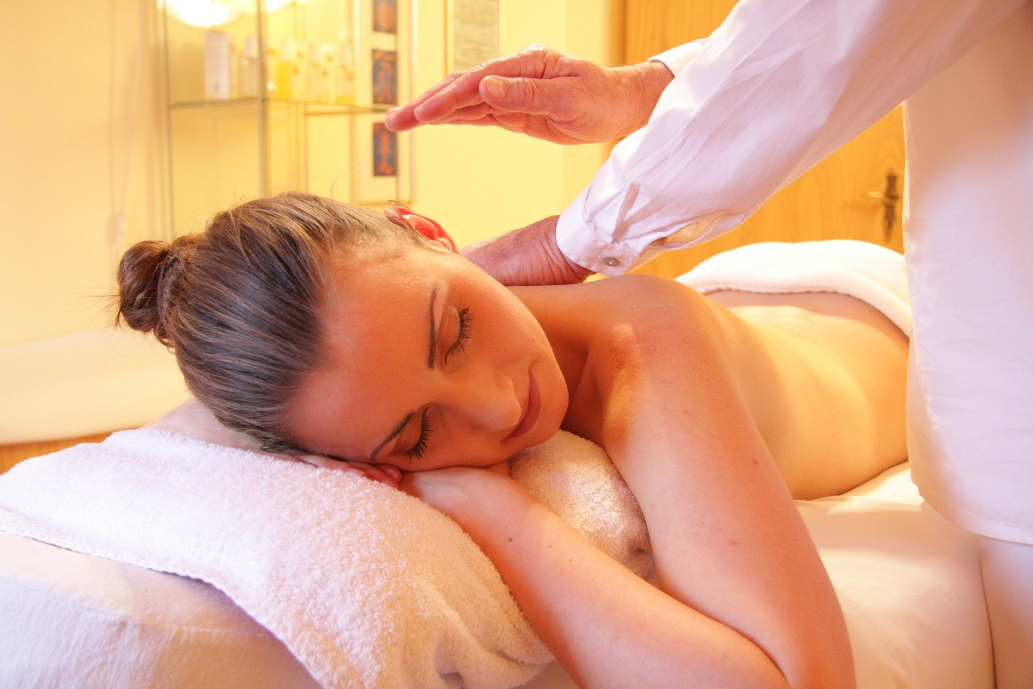
Photo: Pixabay

Helpful Tips to Help to Look and Feel Your Absolute Best Through Self-Care
We all know that self-care is such an important aspect of wellness, yet sometimes it’s easy to neglect in this busy world. Self-care is crucial for maintaining balance, staying healthy in body and mind, and leading a life of purpose.
But did you know that there are six forms of self-care that you should focus on to feel great in every aspect of life? Courtesy of Hair by Tricia, read on to learn about the different ways you can pay special attention to each of these areas of self-care to look and feel your best.
1. Personal Self-Care
If you’re wondering what personal self-care is, it’s all about the basic yet important necessities to feel like your life is going in the direction that you want it to go. This includes things like setting and achieving goals, pursuing passions and hobbies, and creating a concrete financial plan. It also encompasses taking the time to truly get to know yourself and what you want out of life. For example, if you’ve always wanted to earn your master’s degree, you could take the leap and go back to school. An online MBA program would be helpful for those wanting to climb the corporate ladder or open their own company thanks to courses in finance and leadership; similarly, if you’re more the creative type, getting a degree in graphic arts would open up a wide variety of new career possibilities.
2. Emotional Self-Care
To process feelings healthily, it’s beneficial to create daily habits that address your emotional needs. Although it often takes practice, being mindful of the things you say to yourself is key in feeling great. To work on this aspect of self-care, you may want to start a nightly gratitude journal or write down your feelings, practice mindful meditation for 20 minutes each day, or start a routine of speaking 3-5 minutes of positive affirmations to yourself in the mirror every morning.

One good way to set aside time for self-care is to actually create a space where you can do so without distraction. For instance, if you have a spare bedroom, transform this space into a comforting, relaxing area for meditation. And these changes may have a dual benefit; not only will you have a space to relax and care for yourself emotionally, but you could also boost the value of your home if you sell.
3. Physical Self-Care
What’s the first thing that comes to mind when you think of self-care? If you’re like most of us, it’s probably the physical aspect. This is primarily because if you’re not caring for your body, it’s hard to look and feel your best. Physical self-care encompasses activities like getting exercise before or after work every day, taking a bubble bath, developing a regular sleep routine, feeding your body nutritious foods, and taking care of your appearance. Even something like scheduling an appointment with Hair by Tricia can help you love the way you feel.
4. Mental Self-Care

Mental self-care is all about doing the activities you need to stay mentally healthy. Since there are plenty of factors in the world that can poorly influence our mental health, this is important to take care of to feel your absolute best. Mental self-care can be as simple as reading a good book, listening to your favorite podcast, solving a crossword puzzle, or anything else that stimulates you mentally.

5. Social Self-Care

Did you know that socializing and nurturing relationships with others are a form of self-care? This is highly overlooked, yet can be an incredible confidence booster, stress reliever, and help prevent loneliness. There’s a time and a place to say “no” for your mental health, but it’s important to not get stuck in that pattern. Rather than canceling plans when things get busy, aim to catch up with friends and family weekly, give your mom a call every few days, plan a date night with your partner, or attend an event to meet new people. Social self-care also means removing toxic people from your life and focusing on relationships that help you grow.
6. Practical Self-Care
You know those tasks you dread getting done but are necessary to avoid future stressful situations? Kind of like organizing your inbox, sorting through the files on your desk, and cleaning up your living space — that’s practical self-care. Of course, you can get help for these practical forms of self-care if you don’t have the time or energy for them. For example, if you’re not up for mowing the lawn or trimming the hedges, hire a local lawn care service to handle it for you. You could even use an app like DoorDash to hire someone to pick up a few things at the store for you!

Create a Self-Care Routine That Works for You
Now that you have an understanding of the six forms of self-care, you can start to implement them into your life. Since we all have varying wants and needs, it’s important to create a self-care routine that works for you. By encompassing aspects of all six of these areas, it will be hard not to look and feel your absolute best.

